**VISVESVARAYA TECHNOLOGICAL UNIVERSITY**

**“JnanaSangama”, Belgaum -590014, Karnataka.**



**PROJECT WORK-3 REPORT**

**on**

**E-Learning**

***Submitted by***

**Abhinav Verma (1BM18CS003)**

**Atharv Arya (1BM18CS020)**

**Jai Jain (1BM18CS040)**

**J Anukesh (1BM18CS038)**

***Under the Guidance of***

|  |  |
| --- | --- |
| **Dr. Umadevi V**  **Associate Professor, BMSCE** |  |

***in partial fulfillment for the award of the degree of***

**BACHELOR OF ENGINEERING**

***in***

**COMPUTER SCIENCE AND ENGINEERING**



**B. M. S. COLLEGE OF ENGINEERING**

**(Autonomous Institution under VTU)**

**BENGALURU-560019**

**Sep-2020 to Jan-2021**

**B. M. S. College of Engineering,**

**Bull Temple Road, Bangalore 560019**

(Affiliated To Visvesvaraya Technological University, Belgaum)

**Department of Computer Science and Engineering**



**CERTIFICATE**

This is to certify that the project work entitled “**E-Learning**” carried out by **Abhinav Verma (1BM18CS003), Atharv Arya (1BM18CS020),Jai Jain (1BM18CS040) and J Anukesh (1BM18CS038)** who are bonafide students of **B. M. S. College of Engineering.** It is in partial fulfillment for the award of **Bachelor of Engineering in Computer Science and Engineering** of the Visveswaraiah Technological University, Belgaum during the year 2020-2021. The project report has been approved as it satisfies the academic requirements in respect of **Project Work-3 (20CS5PWPW3)** work prescribed for the said degree.

**Signature of the Guide                 Signature of the HOD**

Dr. Umadevi V Dr. Umadevi V

Associate Professor Associate Prof. & Head, Dept. of CSE

BMSCE, Bengaluru BMSCE, Bengaluru

**External Viva**

**Name of the Examiner                                                                   Signature with date**

1._____________________________ ________________________

2. _____________________________ _________________________

**B. M. S. COLLEGE OF ENGINEERING**

**DEPARTMENT OF COMPUTER SCIENCE AND ENGINEERING**



**DECLARATION**

We, **Abhinav Verma (1BM18CS003), Atharv Arya (1BM18CS020), Jai Jain (1BM18CS040), J Anukesh (1BM18CS038),** students of 5th Semester, B.E, Department of Computer Science and Engineering, B. M. S. College of Engineering, Bangalore, here by declare that, this Project Work-3 entitled "**E-Learning**" has been carried out by us under the guidance of **Dr. Umadevi V,** Associate Professor, Department of CSE, B. M. S. College of Engineering, Bangalore during the academic semester Sep-2020-Jan-2021

We also declare that to the best of our knowledge and belief, the development reported here is not from part of any other report by any other students.

**Signature**

**Abhinav Verma (1BM18CS003)**

**Atharv Arya (1BM18CS020)**

**Jai Jain (1BM18CS040)**

**J Anukesh (1BM18CS038)**

**Introduction**

Web app development for “E-learning”. The app allows the users to learn online through lectures recorded by the college faculty, access to all the important notes, assignments given by teachers from time-to-time and students can also contribute to others by sharing important notes or videos related on any topic.

This E-learning Portal supports following users

a. Student

b. Teacher

**Functionalities under Student Sign-up**

Only a student pursuing their degree from BMSCE can sign-up or register for the app via the sign-up form available under the student section.

The details such as Name, USN, Department, BMSCE e-mail id is to be provided by the student.

**Functionalities under Teacher Sign-up**

Teacher has to sign-up for the app by filling in the form under the Teacher section.

The details such as Name, Department, Email-id has to be provided by the Teacher.

**Functionalities under Student/Teacher Log-in**

On successful registration, Student/ Teacher is required to login to the app via login form available on the app.

The login form takes details such as email-id and password provided during registration as the input.

**Design layouts: Screenshots of Web App**

Sign-up Screens

1. Student

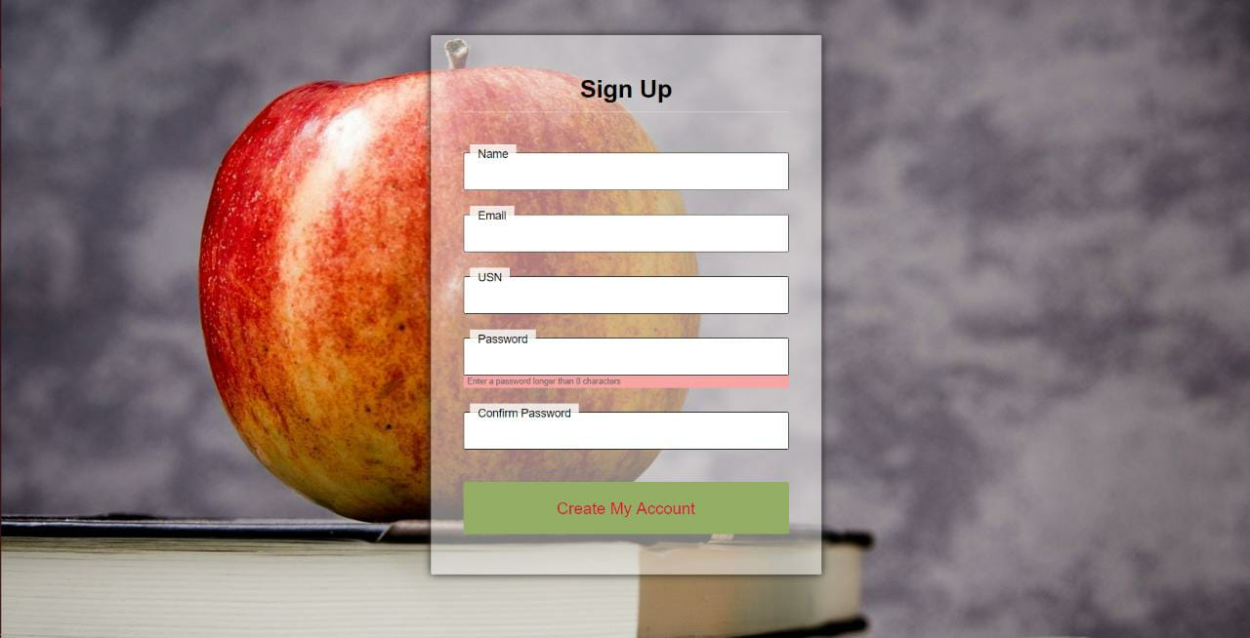

1. **Teacher**

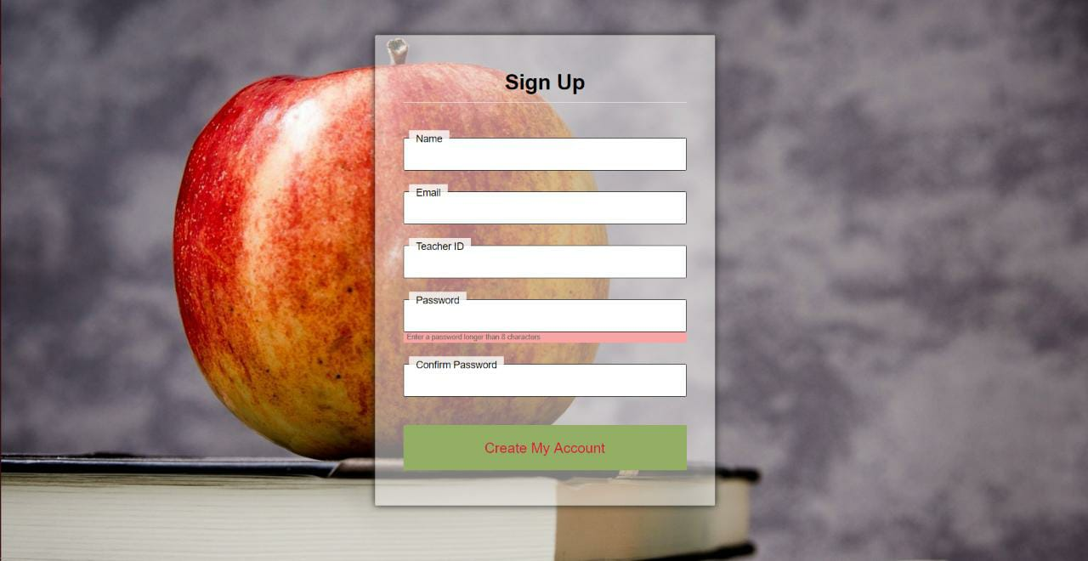

Login Screen: Student/Teacher

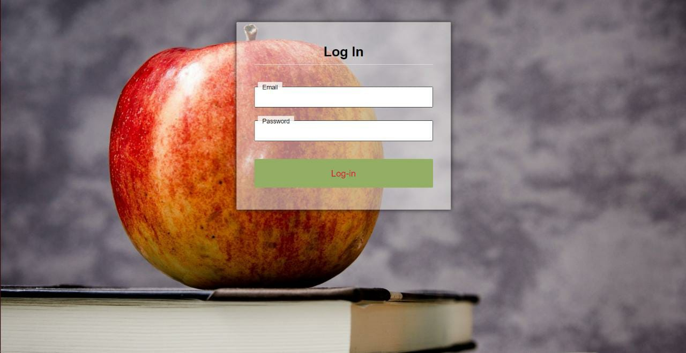

Student Screen

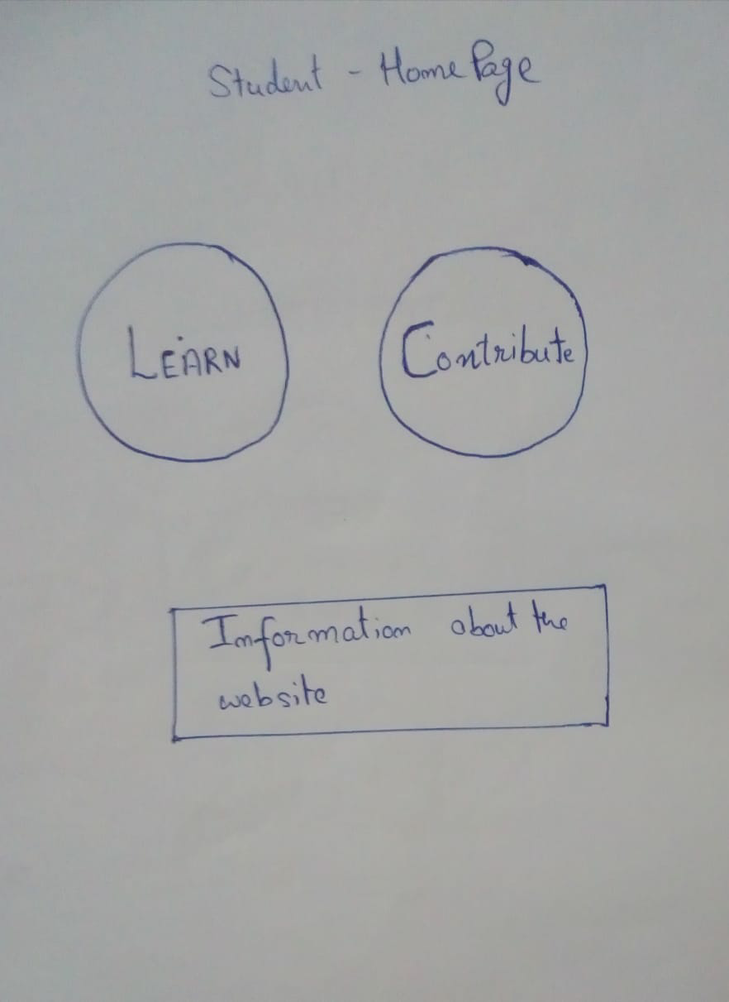

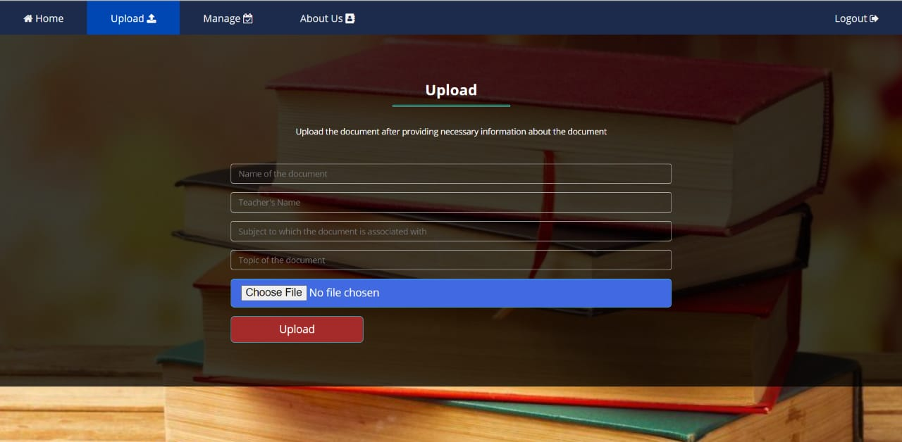

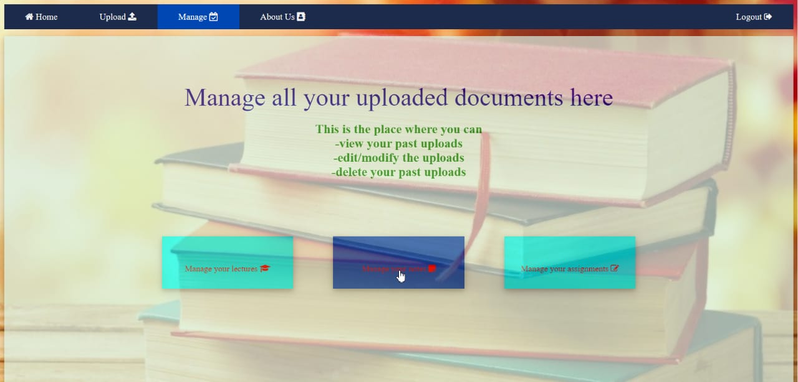

Teacher Screen

